ASSIGNMENT 4.4

Task 1: Auto-Complete a Python Class for Bank Account  
Task Description #1  
• Write a class definition comment and start the constructor for a class called BankAccount with  
account_holder and balance attributes. Use GitHub Copilot to auto-complete the rest of the  
class, including methods to deposit, withdraw, and display balance.  
Week2 -  
Thursday

Expected Output #1  
• Complete class with methods like:  
deposit(self, amount)  
withdraw(self, amount)  
display_balance(self)  
• Output from sample usage:

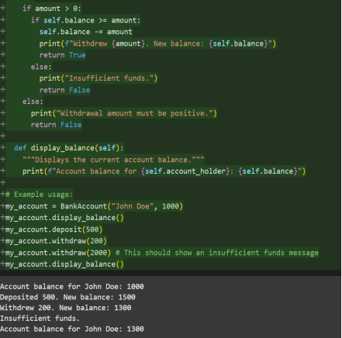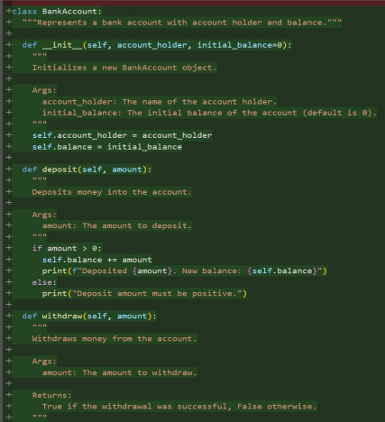Code and Output:

Observation: In this code we can observe that it gives Multiple outputs like account balance, deposite and new balance after deposite , withdraw and new balance after withdraw and lastly it shows the insufficient funds too if we enter more withdraw amount than our balance .

Task 2: Auto-Complete a For Loop to Sum Even Numbers in a List  
Task Description #2  
• Write a comment and the initial line of a loop to iterate over a list. Allow GitHub Copilot to  
complete the logic to sum all even numbers in the list.  
Expected Output #2  
• Code that:  
• Iterates over a list  
• Checks if the number is even using % 2 == 0  
• Accumulates the sum  
• Sample input/output:

Code and Output:

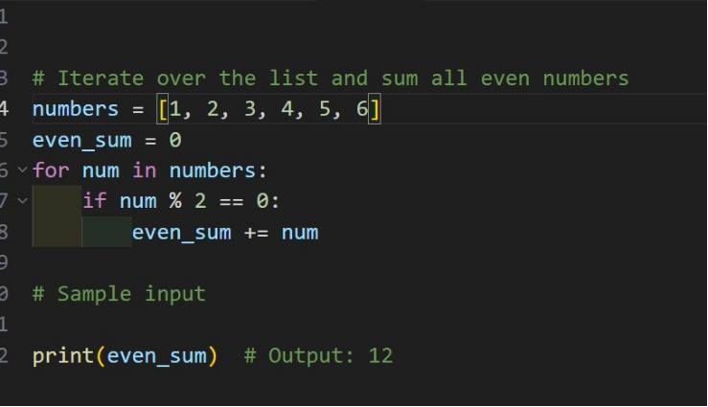

Output;

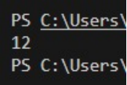

Observation: In this we can observe that the code is autogenerated by the github copilot and it gave the full code by itself.

Task 3: Auto-Complete Conditional Logic to Check Age Group  
Task Description #3  
• Start a function that takes age as input and returns whether the person is a child, teenager,  
adult, or senior using if-elif-else. Use Copilot to complete the conditionals.  
Expected Output #3  
• Function like:  
Output for age_group(45) ➝ "Adult"

Code & Output:

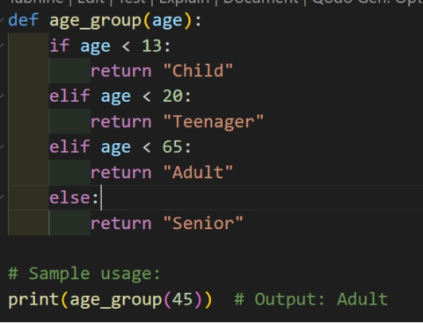

Output:

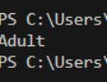

Observation: In this code we can observe that the code is generated by the github copilot and after giving the initial line it created the full code as we wanted .

Task 4: Auto-Complete a While Loop to Reverse Digits of a Number  
Task Description #4  
• Write a comment and start a while loop to reverse the digits of a number. Let Copilot  
complete the loop logic.  
Expected Output #4  
• Functional loop: Output: 4321

Code and Output;

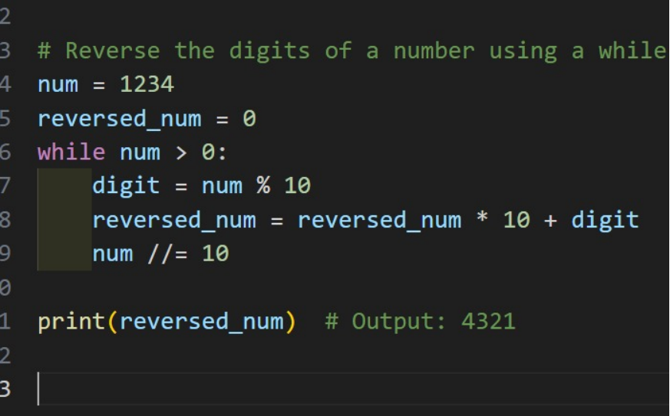

Output:

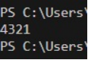

Observation: In this We can Observe that the vs code githut copilot auto generated the full code by entering the initial line of the code and gave the output we wanted

ask 5: Auto-Complete Class with Inheritance (Employee → Manager)  
Task Description #5  
• Begin a class Employee with attributes name and salary. Then, start a derived class Manager  
that inherits from Employee and adds department. Let GitHub Copilot complete the methods  
and constructor chaining.  
Expected Output #5  
• Auto-generated code like:  
Name: John, Salary: 50000, Dept: IT

Code and Output;

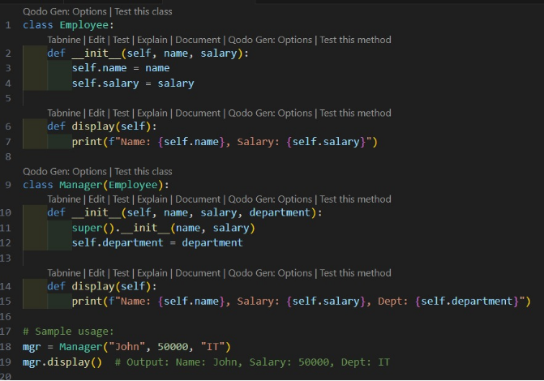

Output:



Observation: In this we can Observe that the vs code github copilot generated the code after we typed the comment for what code we want.